TRAIN RESERVATION SIMULATION

CONTENTS

1.Introduction

2.Modules

3.Diagrams

4.Steps to run

1.INTRODUCTION

The web application is about train reservation. The user can book a ticket only after getting authenticated. New user need to register first. The Availability of trains is not same on all days. The user can choose from the available trains and book the tickets.

Once the ticket is booked the ticket is displayed .The number of tickets booked can also be seen .

2.Modules

A. Registration

-A new user can register and only then he can see the tickets.

B. Login

-An user who is already registered can login to see the trains list and book tickets.

C. Display

-On choose source, destination and date of journey the list of trains available on that day are displayed.

D. Details

-The user gives details to book the ticket. Finally the ticket is displayed.

E. History

-The user can see the list of tickets booked by him .

3. DIAGRAMS

-Use case Diagram

-Class Diagram

-Sequence Diagram

Use-case Diagram

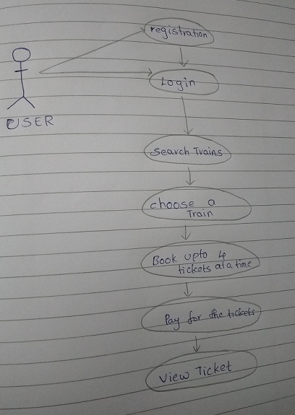

Class Diagram

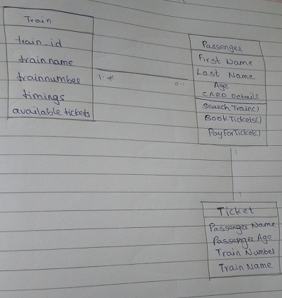

Sequence Diagram

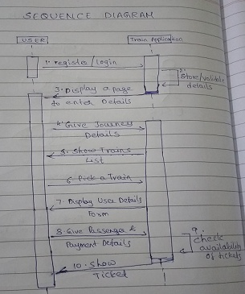

Steps to run

-The user should have MySQL database and a “trains” table with data in it.

-Give the database credentials in application.properties file.

-run the program.

-localhost :{ port}/login is the only accessible URL.

-localhost :{ port}/welcome is the page to add source, destination and date of journey.

-localhost :{ port}/trains displays the list of trains.

-localhost:{port}/payment displays form to enter user details.

-localhost:{port}/ticketconfirmation displays the ticket.

-localhost :{ port}/history displays the list of tickets booked by the user before.